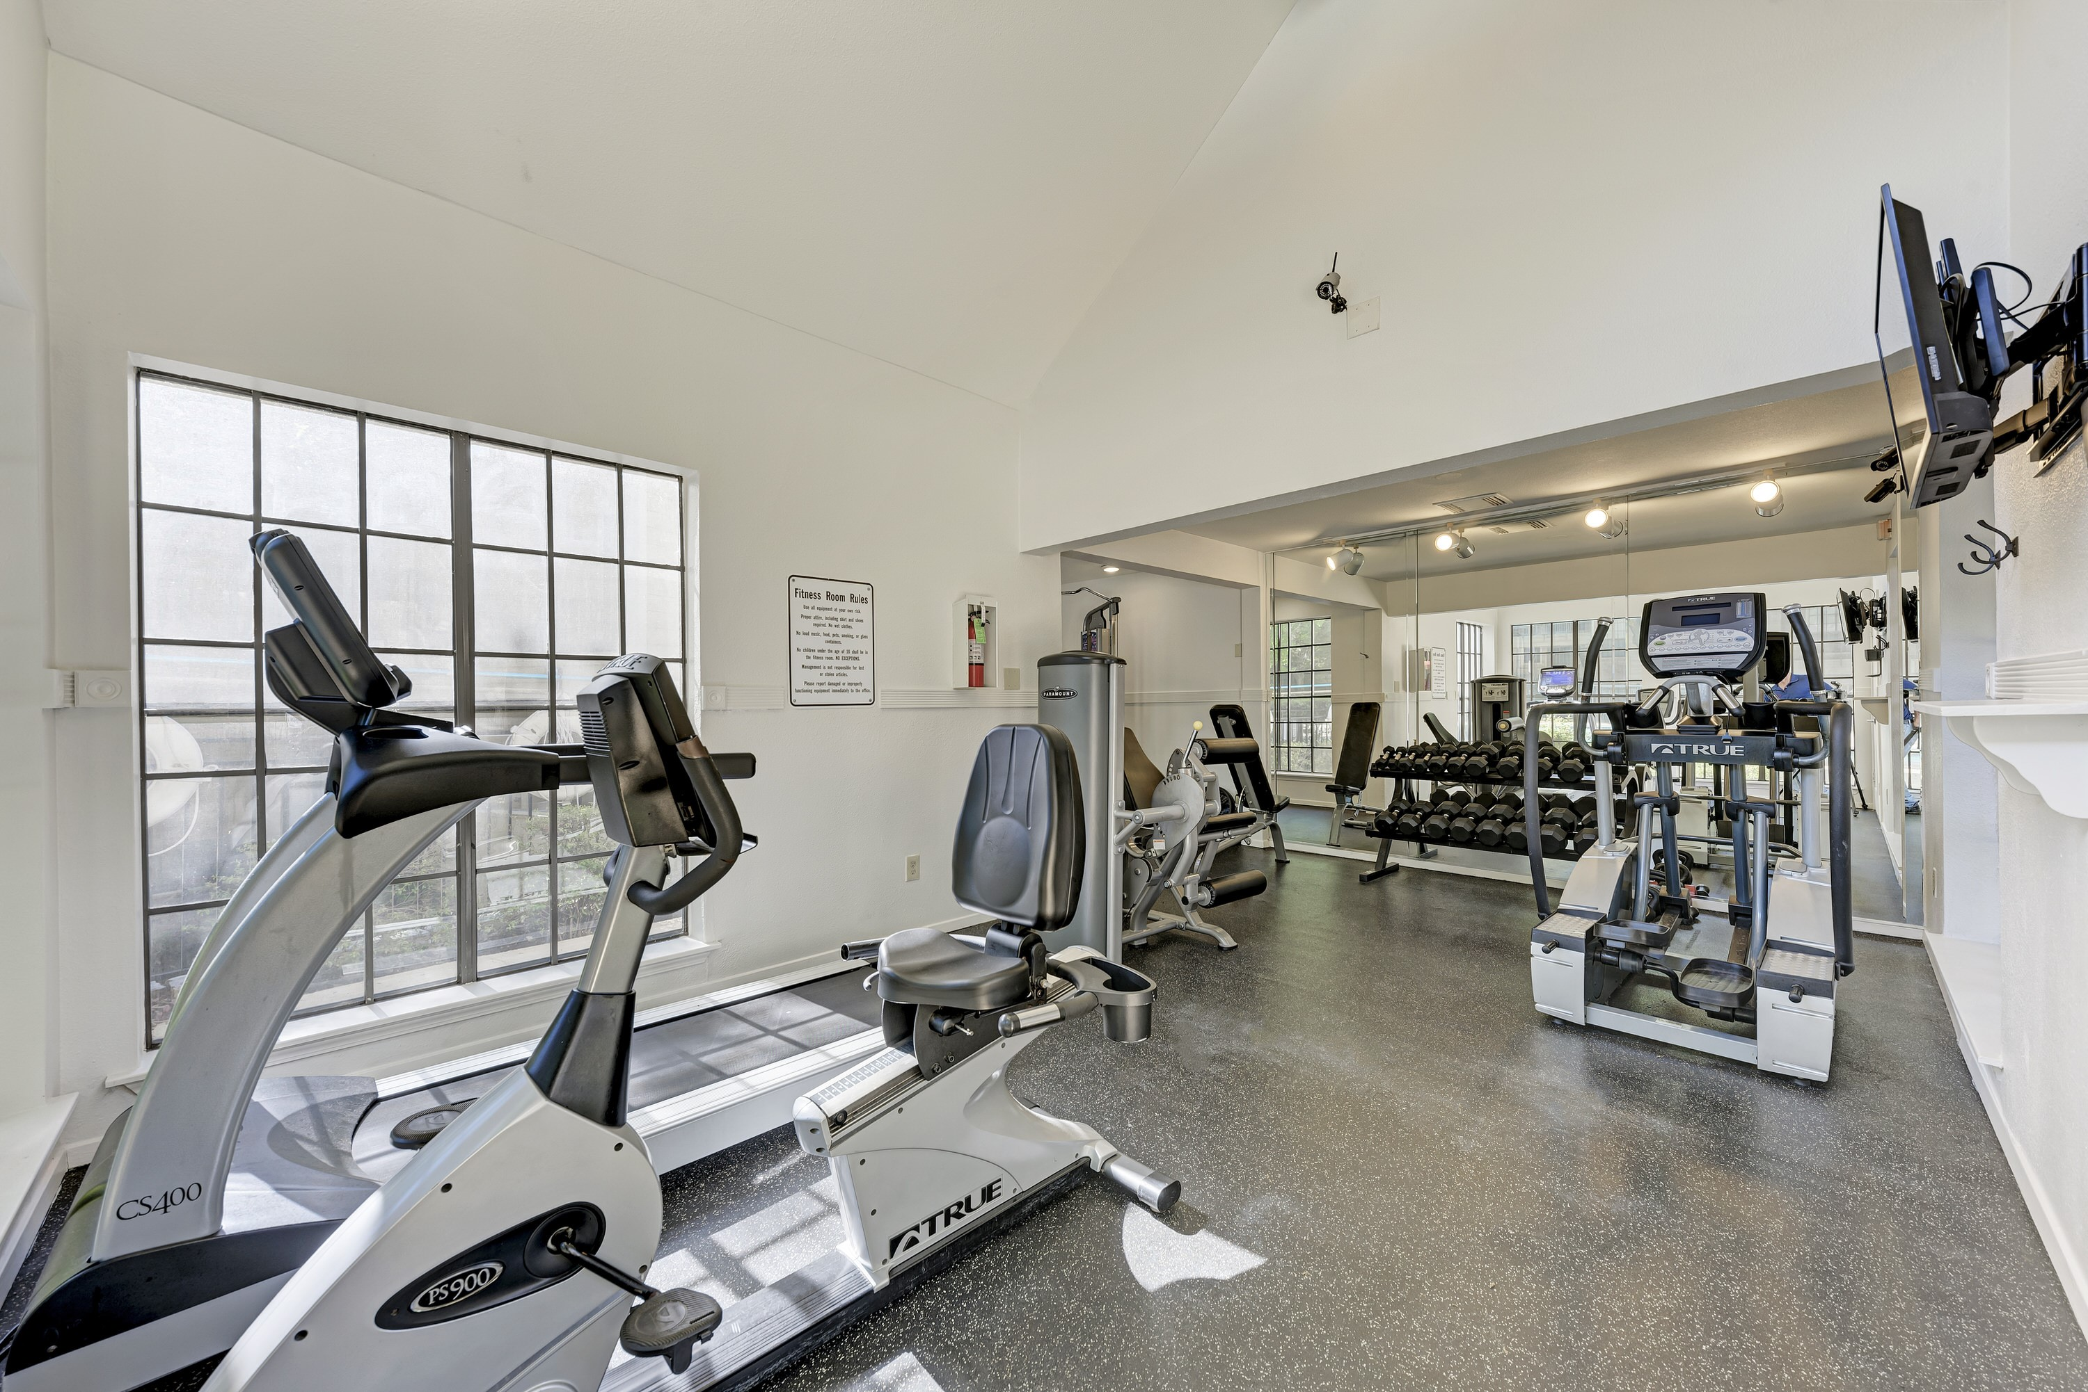
1114 CAMINO LA COSTA
AUSTIN, TX 78752

 Scan Me

Magnolia Court Apartments
Uptown living without the downtown prices
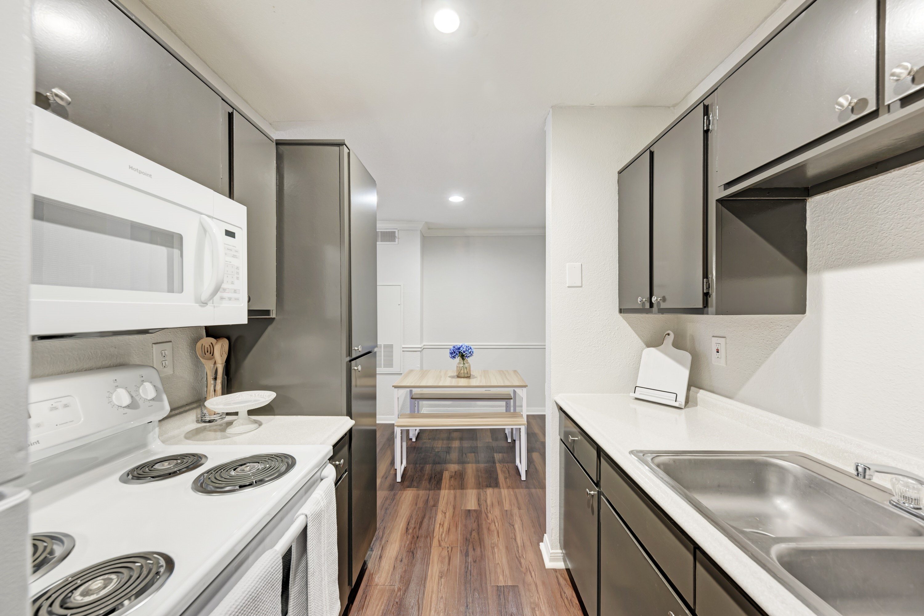
Nested in the heart of Austin, you’ll find Magnolia Court the perfect balance of comfort and style. Whether you are lounging at the pool, pumping some iron at our fitness centre, or strolling under the canopy of century old oak trees, you will experience the essence of living! Magnolia Court is more than just a home, it’s a lifestyle!
Features & Amenities
Resort-style pool •Gated entry •Private fitness center
Clothes care center •Pet friendly •Washer & dryer connections* •Fireplaces* •Microwaves • Crown Molding •Ceiling fans •Spacious walk-in closets
Nightly courtesy patrol •Rich vinyl planking
